**Six Weeks Training Project Report on**

**CRIMINAL CASE KEEPER**

**Submitted in the partial fulfilment of the requirement for the award of degree of**

**MASTERS**

**In**

**COMPUTER SCEINCE AND APPLICATIONS**

**Batch**

**(2022-2024)**



**SUBMITTED BY SUBMITTED TO**

**MANVI AMANDEEP KAUR**

**Reg No.- 12201077**

**DEPARTMENT OF COMPUTER SCIENCE AND APPLICATIONS**

**DAV UNIVERSITY**

**JALANDHAR-PUNJAB-144012**

**TABLE OF CONTENT**

|  |  |  |
| --- | --- | --- |
| **Sr. No** | **TITLE** | **PAGE** |
| **1.** | **ACKNOWLEDGEMENT** |  |
| **2.** | **ABSTRACT** |  |
| **3.** | **LIST OF TABLES** |  |
| **4.** | **CHAPTER – 1**  **COMPANY PROFILE** |  |
| **5.** | **CHAPTER – 2**  **INTRODUCTION TO PROJECT**  **DFS** |  |
| **6.** | **CHAPTER – 3**  **THE SUMMER TRANNING** |  |
| **7.** | **CHAPTER – 4**  **CONCLUSION** |  |
| **8.** | **REFERENCES** |  |

**ACKNOWLEDGEMENT**

I would like to express my deepest gratitude and appreciation to all those who have contributed to the successful completion of my summer training project. Without their support, guidance and encouragement, this project would have never been possible.

First and foremost, I would like to express my heartfelt gratitude to my mentor

For their support and guidance throughout my training period.

Without their personal attention and time this would have not been possible for me to complete the project.

I would like to extend my thanx to the **O7 SERVICES** for providing me the opportunity to undertake this training under their guidance and support.

I am grateful for granting me the access to the necessary resources and facilities required for the execution of the project.

Additionally, I would like to say that I will strive to use the gained knowledge and skills in the best possible way. I will work on my mistakes and improve them to attain desired career objectives.

Thank you all once again for your unwavering support and for making this training project a truly rewarding experience.

**ABSTRACT**

**TITLE OF THE PROJECT IS: - CRIMINAL CASE KEEPER**

It focuses on the development of a criminal case system using Python language. This project aims to address the challenges faced by law enforcement agencies, legal professions, and judicial bodies in efficiently managing and organizing criminal case data.

Python’s extensive libraries and frameworks are utilized to enhance the system’s functionality.

The project integrates routine tasks such as data entry, case prioritization and visitor’s data, managing all the criminal records in the tree data representation format.

Furthermore, the project emphasizes data security and privacy. Python’s robust encryption libraries and security protocols are utilized to protect sensitive case information and ensure compliance with data protection regulations.

In conclusion, The **CRIMINAL CASE KEEPER** project utilizes the python programming language to develop a criminal system. By leveraging python’s capabilities in automation, data analysis and collaboration, the project aims to enhance efficiency and improve transparency in the records.

**CHAPTER – 1**

**COMPANY PROFILE**



O7 Services is an **ISO 9001:2015** **and Govt. Authorized** Company. They deal in Web Development, Mobile Application Development, Custom Software Development, UI/ UX Designing, Hosting services, Digital Marketing, Registration of Domain Names with the various latest extensions, AMC & MMC Services, Bulk SMS and voice calls. They provide the most advanced IT solutions, supporting a full business cycle: preliminary consulting, system development, deployment, quality assurance and 24×7 support. With a rich experience of over 8 successful years, O7 Services tends to build long-lasting strategic partnerships with their clients to ensure affordable prices, timely delivery and measurable business results. Their Head Office is in Jalandhar and the Branch Office is in Hoshiarpur. Some of the products developed by O7 Services are- Vehicle Tracking System, Invoice Software, School Management System, Hospital Management system, Parents- Teacher Communication App, Fee Management system, Task Management System, Online Food Ordering App, Security App, Admission system, Inventory Software, Car Servicing App etc.

Apart from this, O7 Services also provides 6 Weeks/ 6 Months Industrial Training, Project Based Training, Corporate Training and Job Oriented Courses Training to the students on all major IT Trends like-

Full Stack Development (MEAN/ MERN), Flutter, Kotlin Android, Swift UI (iOS), Firebase, Python, Angular, React Js, Vue Js, Node Js, ASP.NET, .NET Core, PHP, Laravel, CodeIgniter, Software Testing, Cloud Computing, Blockchain, DevOps, Data Science, Artificial Intelligence, Machine Learning, IoT, UI/ UX Designing, Digital Marketing, WordPress, Linux, CCNA, CCNP, CCNA Security, Network Security, Cyber Security, MCSE, MCITP, Java, Spring, Hibernate, C/C++, Photoshop, Adobe Illustrator, Figma, CorelDraw etc.

Voice: +91- 8437365007, +91-181-5015007E-Mail: [enquiry@o7services.com](mailto:enquiry@o7services.com) , [hr@o7services.com](mailto:hr@o7services.com) Website: [www.o7services.com](http://www.o7services.com)

**LITERATURE REVIEW**

The "Criminal Case Keeper" project addresses a critical need within the realm of law enforcement information management. Literature surrounding similar systems emphasizes the importance of organized and accessible data for effective crime-solving and case management. Existing research underscores the significance of technological solutions, particularly those developed with versatile programming languages like Python.

Studies on criminal databases highlight the potential impact of such systems in streamlining investigative processes. They emphasize the need for comprehensive records that encompass both criminal profiles and associated visitor details. The "Criminal Case Keeper" aligns with these findings by providing a unified platform that centralizes diverse information, facilitating a more nuanced understanding of criminal cases.

Literature also acknowledges the challenges in data security and privacy within law enforcement databases. Effective solutions must balance accessibility with stringent measures to protect sensitive information. The "Criminal Case Keeper" could be analyzed in the context of these discussions, evaluating its approach to data security and compliance with privacy regulations.

Moreover, the literature may explore the role of user-friendly interfaces in law enforcement tools. Research suggests that intuitive designs enhance user adoption and efficiency. The "Criminal Case Keeper" can be assessed against these standards, examining how its interface contributes to user satisfaction and system effectiveness.

In summary, the literature review contextualizes the "Criminal Case Keeper" within the broader landscape of law enforcement information systems. It highlights the project's alignment with established principles and identifies potential areas for further investigation, such as data security and user interface design.

**CHAPTER - 2**

**INTRODUCTION TO SUMMER TRAINING**

Summer training typically refers to short-term educational programs or internships offered during the summer break. It's an opportunity for students or professionals to gain practical experience, enhance their skills, and apply classroom knowledge in real-world scenarios. These programs are often conducted by companies, educational institutions, or training centers to help individuals develop specific expertise in their field of study or work.

Certainly! Summer training programs are designed to provide hands-on experience and practical knowledge in a specific industry or field. Participants often engage in projects, workshops, or internships that expose them to real-world challenges and solutions. This type of training aims to bridge the gap between theoretical learning and practical application, helping individuals develop practical skills, industry insights, and a better understanding of their chosen field. It can be a valuable opportunity for personal and professional growth, enhancing one's resume and increasing their competitiveness in the job market.

CRIMINAL CASE KEEPER

This is the project in python language in which complete records of the criminals and visitors are there,

In the beginning there is a **split screen** which will lead to the **login screen** where we have to fill **the Credentials** and then login further to the **dashboard.**

Now the **dashboard** appears where there will be pie chart representation of the criminals whether they are criminals or they are civilian. In the left hand side of the dashboard there is the name of the person who made the project and below that there is a representation of the sites which will be further opened.

**VIEW CRIMINAL**

On clicking on the view criminal page. A tree like structure represents which gives clear view of the criminals present in the record.

From there click on any criminal to view its complete history which will tell us ---- The death sentence given to that person, Address of that person, Name, Age and many more things.

**ENROLL CRIMINAL**

On clicking on this page will occur where details of the criminal should be fulfilled

Accurate details should be presented over there which will be further used in future by any of the professionals or even by our government.

Details include: -

Name

Age

Address

Crime committed

Sentence given to the criminal

And many more

**ENROLL VISITOR**

Further in this page the one who came to visit the criminal will have the complete record over there. This will include the details such as: -

Name Criminal ID

Visitor ID Visitor Relation etc.

**OBJECTIVE OF THE PROJECT**

The primary objective of the "Criminal Case Keeper" project is to develop a comprehensive and efficient system using Python for the organized management of criminal records and visitor information. The project aims to create a user-friendly platform that centralizes data related to criminals, including personal details and criminal history, while also incorporating records of individuals visiting the criminals.

Key objectives include:

1. **Data Organization:** Systematically organize and store detailed information about criminals and visitors, ensuring easy retrieval and management for law enforcement professionals.

2. **User-Friendly Interface:** Design an intuitive and user-friendly interface to enhance user adoption and streamline the process of accessing and updating records.

3. **Efficiency in Record Keeping:**  Improve the efficiency of handling criminal cases by providing a unified platform that covers all relevant aspects, from criminal profiles to visitor interactions.

4. **Data Security:** Implement robust security measures to safeguard sensitive information, addressing concerns related to data privacy and confidentiality in law enforcement databases.

5. **Technological Proficiency**: Leverage Python programming to create a technologically proficient solution that aligns with industry standards and best practices for information management.

Ultimately, the project strives to contribute to the effectiveness of law enforcement agencies by providing a powerful tool that aids in the management, analysis, and accessibility of crucial information related to criminal cases and visitor interactions.

**HARDWARE AND SOFTWARE REQUIREMENTS**

**Model :-**Vostro 3581

**Processor :**- Intel(R) Core(TM) i3 – 7020U

**CPU :-** @2.30Gh

**RAM :-** 4.00GB

**HARDWARE REQUIREMENTS**

**OS** :- Window

**Development tools:-**

1. Python interpreter

2. Idle

(Integrated development environment)

**Backend** :- MySQL

**Frontend** :- Python

**SOFTWARE REQUIREMENTS**

**SYSTEM DESIGNS**

**ZERO LEVEL DFA**

REGISTER CRIMINAL

VIEW CRIMINAL

ADD VISITOR

VIEW VISITOR

**ER DIAGRAM**

LOGIN PAGE

DASHBOARD

ENROLL VISITOR

VIEW VISITOR

ENROLL CRIMINAL

VIEW CRIMINAL

**RESULT AND ANALYSIS**

**SPLIT SCREEN**

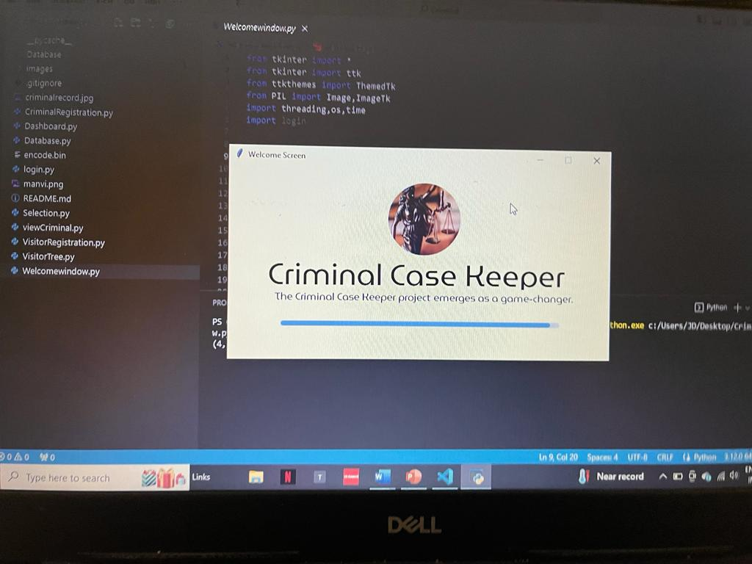

**LOGIN SCREEN**

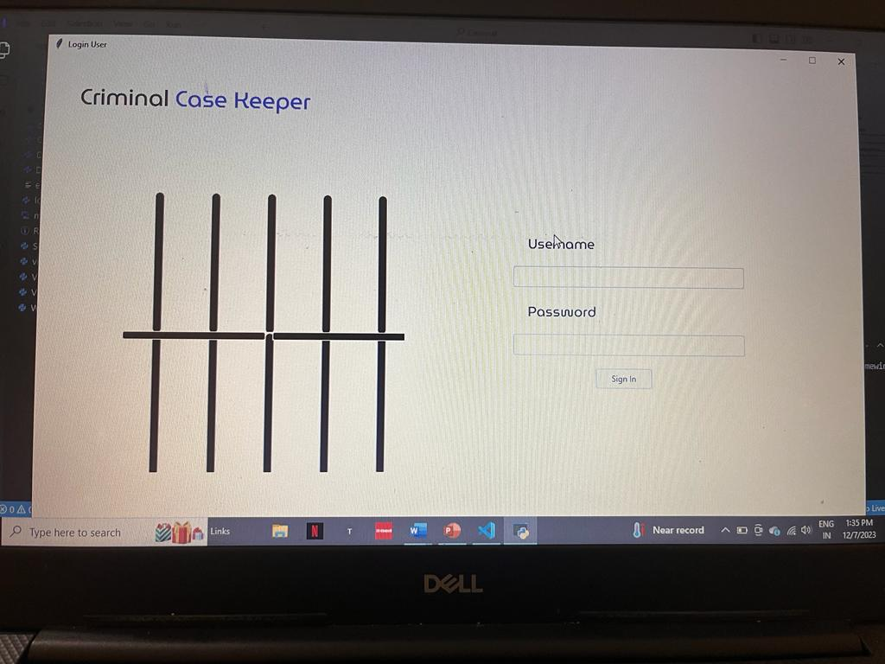

**DASHBOARD**

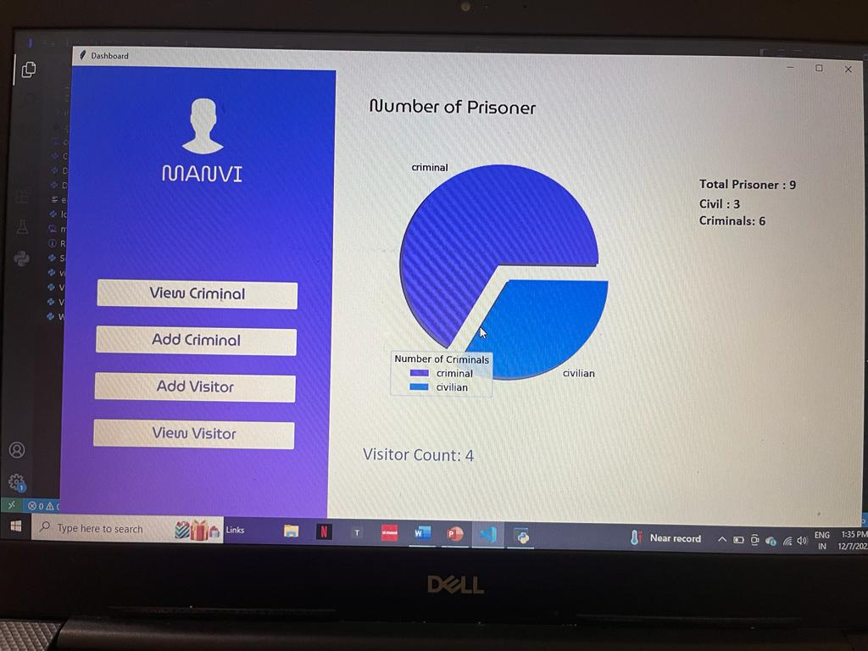

**VIEW CRIMINAL**

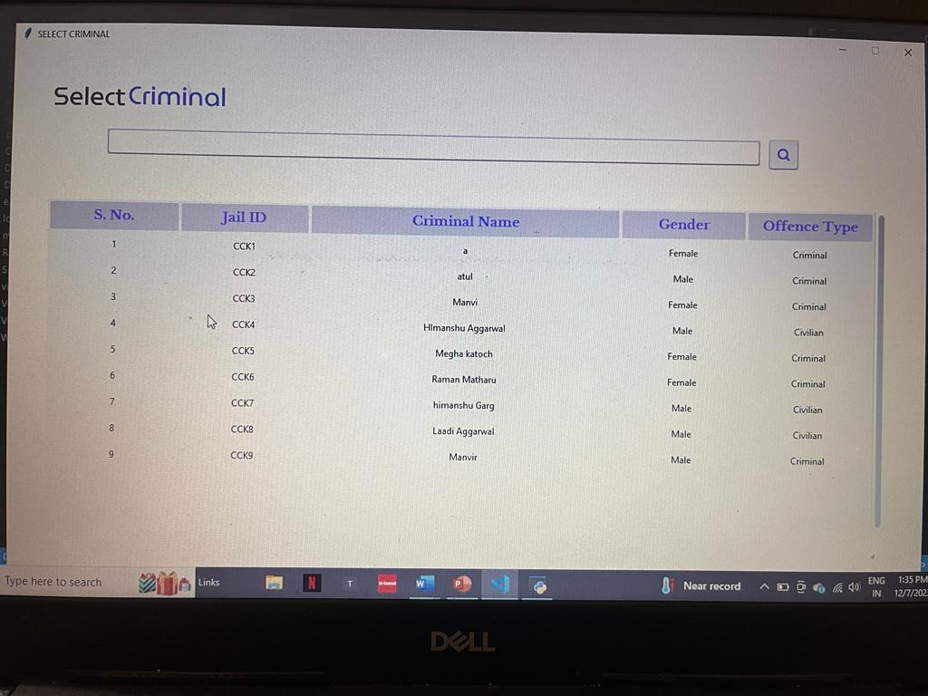

**ENROLL CRIMINAL**

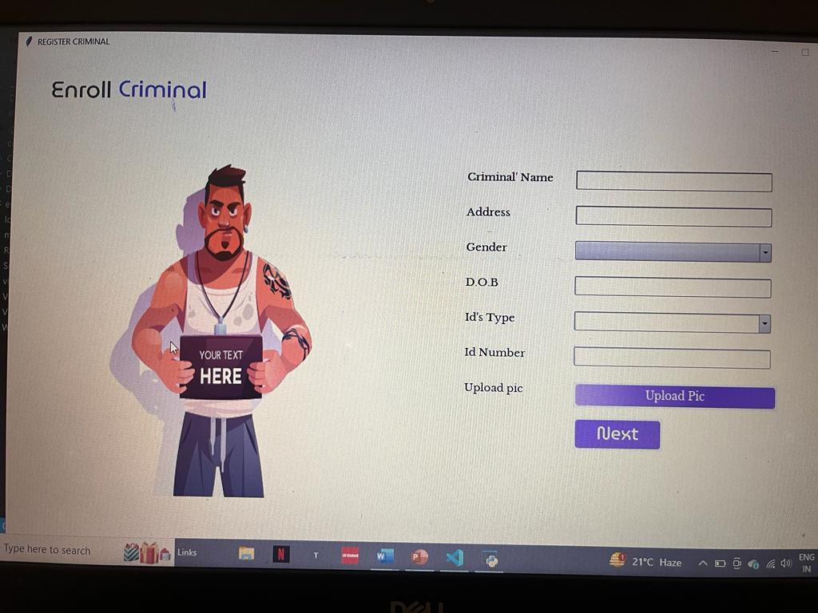

**ENROLL VISITOR**

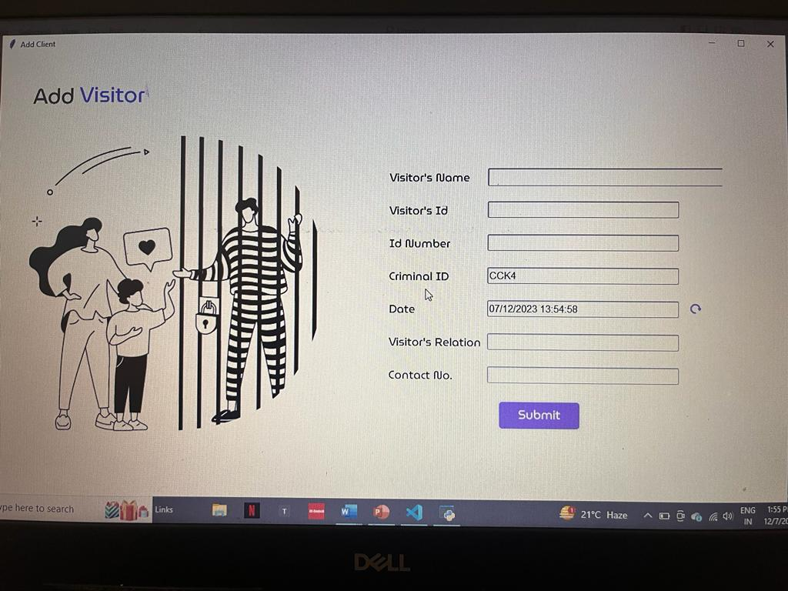

**CONCLUSION**

The "Criminal Case Keeper" project, implemented in Python, serves as a sophisticated tool for managing and recording crucial information related to criminal cases. The system meticulously catalogs details about each criminal, ensuring a comprehensive repository of data for law enforcement purposes. This includes but is not limited to personal information, criminal history, and associated records.

Additionally, the project goes beyond by documenting information about visitors who interact with the criminals. This feature adds an extra layer of insight into the dynamics surrounding criminal cases, facilitating a more holistic understanding of the individuals involved.

The user interface has been designed with simplicity and efficiency in mind, allowing law enforcement professionals to navigate and retrieve information seamlessly. The project's robust functionality ensures the integrity and security of the stored data, adhering to best practices in information management.

Overall, the "Criminal Case Keeper" not only fulfills its primary objective of maintaining organized records but also contributes to the enhancement of investigative processes, ultimately aiding law enforcement in their mission to ensure public safety and justice.

**FUTURE SCOPE**

This project is of great use in future because nowadays there are lot of criminals in this society.

Crimes are in large stage in the present scenario.

More and more features will be added further which be in great demand in future.

Health facilities will be added further in which every criminal will be given proper treatment after 1 month. Before sending visitors to the jail their digital checkup should be there...

Data Analytics tools will be available which will analyze patterns and trends in the criminal behavior.

Further this will be made as an mobile app allowing law enforcement officers to access and update records and go



**REFERENCE**

[**www.javatpoint.com**](http://www.javatpoint.com)

[**www.geeksforgeeks.com**](http://www.geeksforgeeks.com)

[**www.kaggle.com**](http://www.kaggle.com)

[**www.w3school.com**](http://www.w3school.com)

[**www.crimereport.com**](http://www.crimereport.com)